PRACTICAL -02
Aim:
To write a program to implement Linear Search and Binary Search algorithms and analyze their time complexity.
Theory:
Searching is the process of finding the location of a specific element in a list of elements.
- Linear Search checks every element of the array sequentially until the desired element is found or the list ends. It works on both sorted and unsorted arrays. Its time complexity is O(n) in the worst case, since every element may need to be checked.
- Binary Search works only on sorted arrays. It repeatedly divides the search interval in half — comparing the target with the middle element, and discarding the half in which the target cannot lie. Its time complexity is O(log n), which makes it much faster than linear search for large datasets.
- Comparing execution time of both algorithms shows that binary search performs significantly better than linear search as the size of the array increases, although linear search may occasionally be faster for very small arrays or when the element is near the beginning.
Algorithm:
- Input the array elements and the element to be searched.
- Linear Search: Traverse the array from index 0 to n-1, comparing each element with the target. If found, return the index.
- Record the start time before linear search begins and the end time after it completes; calculate the time taken.
- Sort the array (required for binary search).
- Binary Search: Set low = 0 and high = n-1. Repeat while low ≤ high: find mid = (low+high)/2; if arr[mid] equals target, return mid; if target is smaller, set high = mid-1; else set low = mid+1.
- Record the start time before binary search begins and the end time after it completes; calculate the time taken.
- Display whether the element was found (with index) for both searches.
- Display and compare the time taken by both algorithms.

# 1. LINEAR SEARCH
def linear_search(arr, target):
for i in range(len(arr)):
if arr[i] == target:
return i # index found
return -1 # not found

# 2. BINARY SEARCH (array must be sorted)
def binary_search(arr, target):
low, high = 0, len(arr) - 1
while low <= high:
mid = (low + high) // 2
if arr[mid] == target:
return mid
elif arr[mid] < target:
low = mid + 1
else:
high = mid - 1
return -1

# Recursive version of binary search
def binary_search_recursive(arr, target, low=0, high=None):
if high is None:
high = len(arr) - 1
if low > high:
return -1
mid = (low + high) // 2
if arr[mid] == target:
return mid
elif arr[mid] < target:
return binary_search_recursive(arr, target, mid + 1, high)
else:
return binary_search_recursive(arr, target, low, mid - 1)

# Demo
if __name__ == "__main__":
data = [3, 4, 10, 20, 33, 73, 74, 90 ] # sorted, needed for binary search
unsorted_data = [4, 33, 73, 90, 10, 74, 20, 3]

print("Linear Search (10): ", linear_search(unsorted_data, 10))
print("Binary Search (20): ", binary_search(data, 20))
print("Binary Recursive(74):", binary_search_recursive(data, 74))

Output :
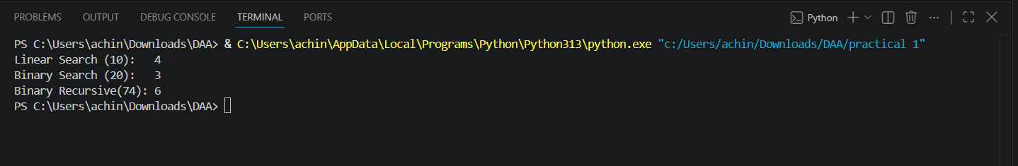

Result:
The program successfully implements Linear Search and Binary Search algorithms in Java and analyzes their execution time using System.nanoTime(). It is observed that Binary Search performs faster than Linear Search for larger datasets due to its O(log n) time complexity, whereas Linear Search has O(n) time complexity.

